Additional files
Increasing soil pH enhances the network interactions among bacterial and archaeal microbiota in alpine grasslands of the Tibetan Plateau

Running title: Increasing soil pH enhances microbial interactions

Beibei Chen¹, Shuaiwei Luo^{1,2}. Beibei Ma¹, Wei Qi^{1,2}, Changdong Cao¹, Zhigang Zhao¹, Shuo Jiao^{3*}, Guozhen Du^{1,2*} and Xiaojun Ma^{1*}
*Correspondence: xjma@lzu.edu.cn
¹School of Life Sciences, Lanzhou University, Lanzhou, 730000, P. R. China;
²Key Laboratory of Arid and Grassland Ecology of Ministry of Education, School of Life Sciences, Lanzhou University, Lanzhou, 730000, P. R. China;
³State Key Laboratory of Crop Stress Biology in Arid Areas, College of Life Sciences, Northwest A&F University, Yangling Shaanxi 712100, P. R. China;

Table S1. Description of node- and network-level topological features in the co-occurrence network for soil microbiota
Level | Topological feature | Description
 | Degree | The number of connected edges per node
 | Betweenness centrality | Extent of a node effects on the connections of other nodes
Node | Eigenvector centrality | Scores weighted the importance of a node connection with other nodes in the network
 | Closeness centrality | Scores weighted average distance of this node to any other node
 | Vertex number | Number of classes
 | Edge number | Number of potential links between associated classes
 | Average path length | The mean over all network distance between all pairs of nodes
 | Average degree | The average connections of each node with another particular node
 | Density | Ratio of the number of nodes and the number of possible edges
Network | Diameter | The greatest distance between the unique nodes in the network
 | Modularity | Scores weighted the number of a graph division into sub-graphs
 | Clustering coefficient | The degree to which the nodes tend to cluster together
 | Degree centralization | Creating a graph level centralization measure from the centrality scores of the nodes
 | Degree assortativity | The level of homophyly of the graph, based on some node labeling or values assigned to nodes
 | Betweenness centralization | The mean of betweenness centrality for all nodes
 | Closeness centralization | The mean of closeness centrality for all nodes
 | Eigenvector centralization | The mean of eigenvector centrality for all nodes

Reference:
1 Newman ME. The structure and function of complex networks. Siam Rev. 2003;45:167-256.
2 Newman ME. Modularity and community structure in networks. Proc Natl Acad Sci USA. 2006;103:8577-8582.

Table S2. Multiple regression analysis to explain the variation caused by environmental factors in network-level topological features of the co-occurrence network for soil microbiota in the Tibetan alpine grasslands
 | Relative importance based on the multiple regression model (P value) for^{b}:
Variableª | Edge number | Average path length | Average degree | Vertex number | Modularity | Degree centralization | Eigenvector centralization | Density
pH | 0.380*** | 0.470*** | 0.410*** | 0.300*** | 0.290*** | 0.370*** | 0.320*** | 0.390***
SM | 0.097** | 0.058 | 0.087* | 0.076* | 0.130 | 0.097 | 0.110 | 0.070
SOM | 0.110 | 0.110 | 0.120 | 0.070 | 0.160 | 0.140 | 0.150 | 0.140
TN | 0.061 | 0.057 | 0.066 | 0.041 | 0.099 | 0.078 | 0.085 | 0.067
TP | 0.120* | 0.077 | 0.110 | 0.130* | 0.065 | 0.086 | 0.081 | 0.081
AP | 0.049 | 0.040 | 0.049 | 0.035 | 0.085 | 0.069 | 0.067 | 0.046
NO₃⁻-N | 0.016* | 0.013 | 0.015 | 0.018 | 0.025 | 0.021 | 0.020 | 0.013
NH₄⁺-N | 0.051 | 0.038 | 0.052 | 0.061 | 0.055* | 0.051* | 0.054* | 0.053
MAT | 0.06* | 0.046 | 0.021 | 0.200*** | 0.028** | 0.023** | 0.036*** | 0.056***
MAP | 0.065 | 0.091 | 0.072 | 0.066* | 0.067 | 0.065 | 0.069 | 0.086***
ªpH, soil pH; SOM, soil organic matter; AP, soil available phosphorus; TN, total nitrogen; TP, total phosphorus; SM, soil moisture content; NO₃⁻-N, nitrate-nitrogen; NH₄⁺-N, ammonium-nitrogen; MAT, mean annual temperature; and MAP, mean annual precipitation
^{b}Statistical significance was tested based on 999 permutations (*P < 0.05, **P < 0.01, and ***P < 0.001).

Table S3. ANOVA of environmental factors correlated with dominant bacterial β-diversity in the Tibetan alpine grasslands
Variableª | Df^{b} | Variance | Pseudo-F | p-value
pH | 1 | 10.09 | 106.27 | 0.001
SM | 1 | 1.31 | 13.81 | 0.001
SOM | 1 | 0.70 | 7.35 | 0.001
TP | 1 | 0.41 | 4.30 | 0.001
AP | 1 | 0.24 | 2.54 | 0.025
NO₃⁻-N | 1 | 0.26 | 2.73 | 0.018
NH₄⁺-N | 1 | 0.22 | 2.31 | 0.043
MAT | 1 | 1.23 | 12.95 | 0.001
MAP | 1 | 0.62 | 6.50 | 0.001
Residual | 176 | 16.71
Axis | df | Variance | Pseudo-F | p-value
CAP1 | 1 | 10.42 | 109.76 | 0.001
CAP2 | 1 | 2.50 | 26.36 | 0.001
CAP3 | 1 | 0.64 | 6.76 | 0.001
CAP4 | 1 | 0.53 | 5.57 | 0.001
CAP5 | 1 | 0.34 | 3.62 | 0.001
CAP6 | 1 | 0.24 | 2.51 | 0.010
CAP7 | 1 | 0.21 | 2.22 | 0.417
CAP8 | 1 | 0.12 | 1.23 | 0.879
CAP9 | 1 | 0.069 | 0.72
Residual | 176 | 16.71
ªpH; soil pH, SM, soil moisture; SOM, soil organic matter; TP, total phosphorus; AP, available phosphorus; NO₃⁻-N, Nitrate-nitrogen; NH₄⁺-N, ammonium-nitrogen; MAT, mean annual temperature; and MAP, mean annual precipitation
^{b}df = degree of freedom, Permutations = 999, and overall model significance: Pseudo-F = 17.64, p = 0.001

Table S4. ANOVA of environmental factors correlated with dominant archaeal β-diversity in the Tibetan alpine grasslands
Variable | df | Variance | Pseudo-F | p-value
pH | 1 | 13.49 | 74.70 | 0.001
SM | 1 | 2.35 | 12.99 | 0.001
SOM | 1 | 1.16 | 6.44 | 0.001
TP | 1 | 0.79 | 4.37 | 0.001
AP | 1 | 0.45 | 2.51 | 0.018
NO₃⁻-N | 1 | 0.49 | 2.71 | 0.017
MAT | 1 | 2.03 | 11.26 | 0.001
MAP | 1 | 1.17 | 6.49 | 0.001
Residual | 177 | 31.95

Axis | df | Variance | Pseudo-F | p-value
CAP1 | 1 | 13.65 | 75.62 | 0.001
CAP2 | 1 | 3.85 | 21.30 | 0.001
CAP3 | 1 | 1.79 | 9.89 | 0.001
CAP4 | 1 | 1.37 | 7.59 | 0.001
CAP5 | 1 | 0.50 | 2.79 | 0.024
CAP6 | 1 | 0.30 | 1.66 | 0.358
CAP7 | 1 | 0.29 | 1.58 | 0.219
CAP8 | 1 | 0.19 | 1.05 | 0.396
Residual | 177 | 31.95
ªpH; soil pH, SM, soil moisture; SOM, soil organic matter; TP, total phosphorus; AP, available phosphorus; NO₃⁻-N, nitrate-nitrogen; MAT, mean annual temperature; and MAP, mean annual precipitation
^{b}df = degree of freedom, Permutations = 999, and Overall model significance: Pseudo-F = 15.18, p = 0.001

Table S5. List of microbiota found in most common and ubiquitous bacterial and archaeal communities in alpine grasslands of the Tibetan Plateau. The list contains data for the relative abundance, ubiquity, and taxonomic identity of microbial taxa, and the Spearman’s correlation coefficient (p < 0.05) between the relative abundance of microbial taxa, environmental predictors, and corresponding ecological cluster.
Table S5 is available in Excel (ZIP 146 kb).

Fig S1. Geographical location of the sampling sites in alpine grasslands of the Tibetan Plateau. Red circles represent alpine meadow sites (n = 42) and black circles represent alpine steppe sites (n = 20).

Fig S2. The degree distribution of the co-occurrence network for soil microbiota in the Tibetan alpine grasslands.

Fig S3. The degree distribution pattern of the co-occurrence network for soil bacteria and archaea and the dominant taxa assigned to high- and -low pH clusters in the Tibetan alpine grasslands.
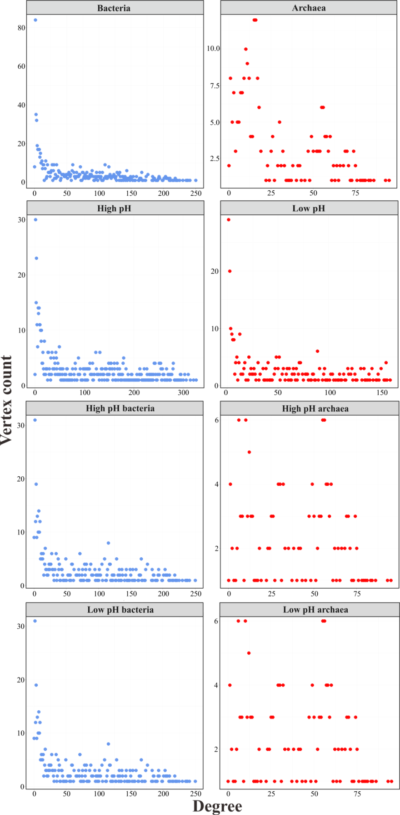

Fig S4. Correlation matrix between environmental factors and network-level topological features of the co-occurrence network for soil microbiota in the Tibetan alpine grasslands. The environmental factors include soil pH (pH), soil moisture (SM), soil organic matter (SOM), total phosphorus (TP), total nitrogen (TN), available phosphorus (AP), nitrate-nitrogen (NO₃⁻-N), ammonium-nitrogen (NH₄⁺-N), mean annual temperature (MAT), and mean annual precipitation (MAP). Significant correlations are shown (*P < 0.05, **P < 0.01, and ***P < 0.001).
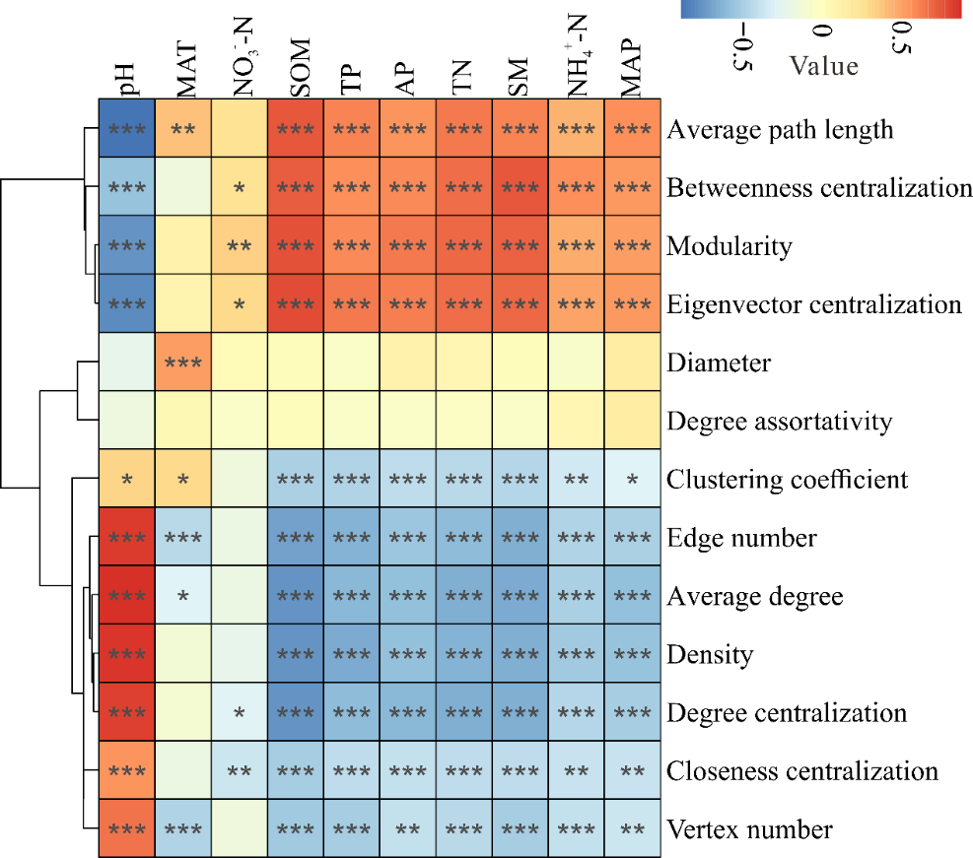

Fig S5. Comparison of environmental factors between the Tibetan alpine meadow and steppe ecosystems. *P < 0.05, **P < 0.01, and ***P < 0.001 based on Wilcoxon rank sum tests.
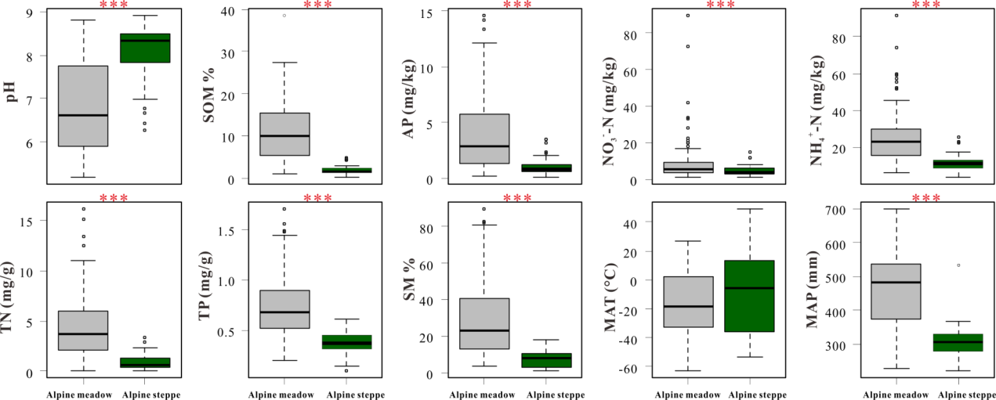

Fig S6. Spatial distribution of soil pH and the density, degree centralization, eigenvector centralization, modularity, and positive edge number within or between kingdoms of the co-occurrence network for soil microbiota in the Tibetan alpine grasslands. The cross-validation (“CV”) of the maps was calculated based on Pearson correlation between the predicted and observed values at each sampling site. Network-level topological features were estimated via linear least-squares regression analysis (pH was log transformed).
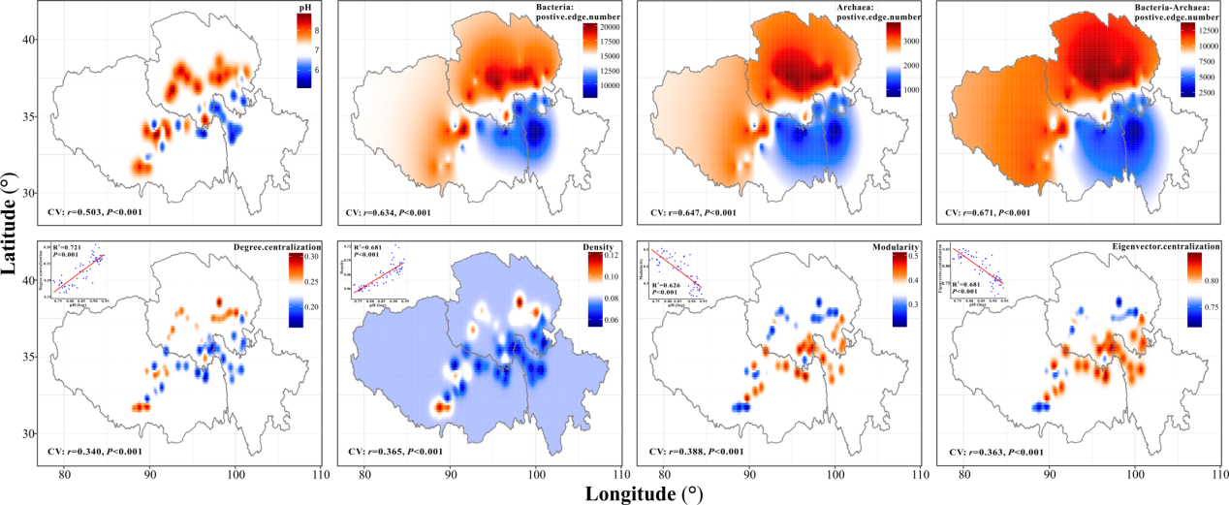

Fig S7. The random forest mean predictor importance (percentage of increase in mean square error [MSE]) of environmental factors as drivers of network-level topological features of the co-occurrence network for soil microbiota in the Tibetan alpine grasslands. The accuracy importance measure was computed for each tree. Percentage increases in the mean squared error) of variables were used to estimate the importance of these predictors, and higher MSE% values imply more important predictors. *P < 0.05, **P < 0.01, and ***P < 0.001. The number of positive and negative edges was estimated via linear least-squares regression analysis as shown in the top right corner of each graph (pH was log transformed).
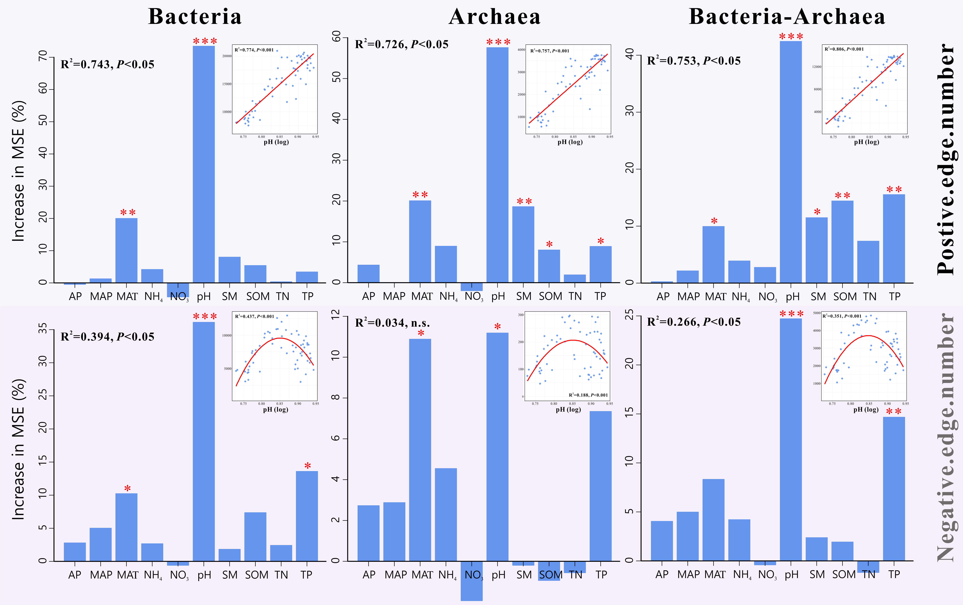

Fig S8. Dominant taxa (genera) of soil bacteria (blue) and archaea (red) assigned to the high- and low-pH clusters in the Tibetan alpine grasslands.
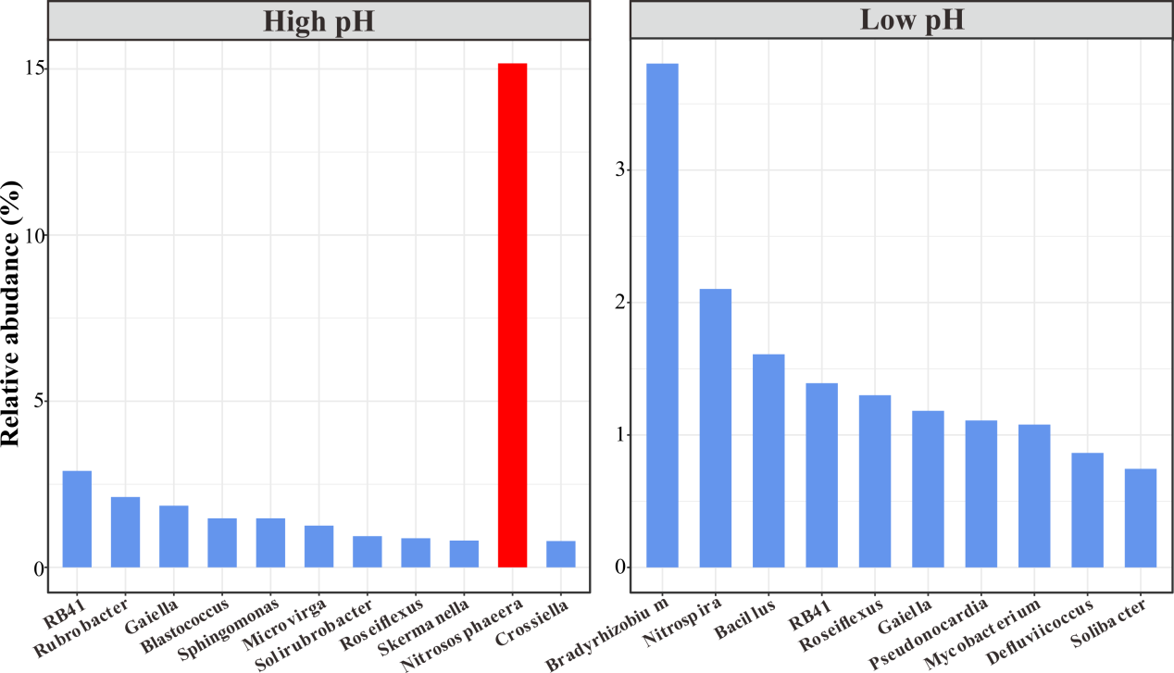

Fig S9. Unique node-level topological features of the dominant bacterial and archaeal taxa assigned to high- and low-pH clusters in the Tibetan alpine grasslands. The degree, betweenness, closeness, and eigenvector centrality are shown. *P < 0.05, **P < 0.01, and ***P < 0.001 based on Wilcoxon rank sum tests.
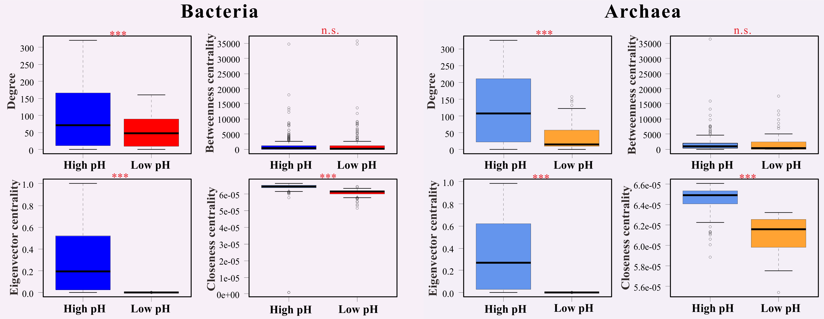

Fig S10. Correlation matrix between environmental and geographical factors in the Tibetan alpine grasslands. The factors include soil pH (pH), soil moisture (SM), soil organic matter (SOM), total phosphorus (TP), total nitrogen (TN), available phosphorus (AP), nitrate-nitrogen (NO₃⁻-N), ammonium-nitrogen (NH₄⁺-N), mean annual temperature (MAT), mean annual precipitation (MAP), longitude, and latitude. Significant correlations are shown (*P < 0.05, **P < 0.01, and ***P < 0.001).
